

Travlr Getaways

CS 465 Project Software Design Document
Version 2.0

Table of Contents

CS 465 Project Software Design Document 1
Table of Contents 2
Document Revision History 2
Instructions 2
Executive Summary 3
Design Constraints 3
System Architecture View 4
Component Diagram 4
Sequence Diagram 6
Class Diagram 6
API Endpoints 8
The User Interface 8

Document Revision History

Version | Date | Author | Comments
1.0 | 09/20/26 | Marwan Alrifaie | Completed Milestone One executive summary, design constraints, and component architecture description
2.0 | 10/04/26 | Marwan Alrifaie | Completed Milestone Two sequence and class explanations and API endpoint table; included both completed diagrams.

Instructions

Fill in all bracketed information on page one (the cover page), in the Document Revision History table, and below each header. Under each header, remove the bracketed prompt and write your own paragraph response covering the indicated information.

Executive Summary

Travlr Getaways is built on a three-tier architecture that keeps the user-facing pages, server logic, and database in separate layers. That separation matters because changes to one part should not ripple out and break everything else, which makes the application easier to update and test as it grows. The completed application will run on the MEAN stack: Node.js handling the server, Express managing routing and web services, Angular powering the administrator single-page application, and MongoDB storing all the application data.

The customer-facing side currently works through Express routes and controllers with Handlebars templates pulling trip information from a local JSON file. Visitors can browse available trips but have no way into the administrative side of things. Down the road, the Angular SPA will give authorized staff the ability to add, edit, and update trip information without a full page reload every time a change is made. That side communicates with the server through a REST API, and trip data will eventually live in MongoDB. Once both sides are drawing from the same database, anything an administrator updates will show up on the customer-facing site automatically.

Design Constraints

Several design constraints guide the development of the Travlr Getaways application:

- Node.js and Express: The server must use Node.js as the runtime environment and Express for routing and server logic.
- Handlebars: The customer-facing website uses Handlebars to display trip information while keeping the current Travlr layout and navigation.
- Local JSON data: The current controller reads trip information from trips.json using fs.readFileSync. This works for the prototype but is not intended for production.
- Angular SPA: The administrator portal will use Angular so authorized users can manage trips through a more interactive interface.
- MongoDB and Mongoose: The local JSON file will eventually be replaced by MongoDB. Mongoose will connect the application to the database and define the trip data model.
- Application security: Administrative features will require authentication, authorization, server-side validation, and secure handling of credentials.

These constraints affect development in several ways:
- Reading the JSON file for every request can reduce performance as the application grows.
- File-based storage cannot safely support multiple administrators updating information at the same time.
- Handlebars pages have less interactivity because the server must render and return a new page.
- Moving to MongoDB and Angular will require additional API development, validation, error handling, and testing.
- The application must also work across different browsers, screen sizes, and network conditions.

System Architecture View

Component Diagram

The component diagram divides the Travlr Getaways application into Client, Server, and Database areas. The main components include:
- Web Browser: Displays the customer-facing website and the Angular administrator SPA.
- Traveler Portfolio: Represents the travel information and interface presented to the user.
- Graphic Library: Provides the images and other visual files used by the website.
- Client Session: Keeps track of the user’s browser session and sends session information to the server.
- Node.js and Express Server: Receives requests, runs controllers, renders Handlebars pages, and provides REST API endpoints.
- Authentication Server: Checks administrator credentials before allowing access to protected features.
- Server Session: Maintains the authenticated administrator session and controls access.
- Traveler Database: Handles requests involving trip records.
- Mongoose ODM: Connects the application to MongoDB and maps JavaScript objects to database documents.
- MongoDB: Stores the trip information that will be used by both the customer and administrator interfaces.

The diagram below shows how these components are connected. The Web Browser works with the Traveler Portfolio, while the Graphic Library supplies the images used by the website. The Client Session connects the client side to the Authentication Server and Server Session. On the server side, the Server Session connects to the Traveler Database and Mongoose ODM. Mongoose connects the server components to MongoDB so the application can store and retrieve trip information.
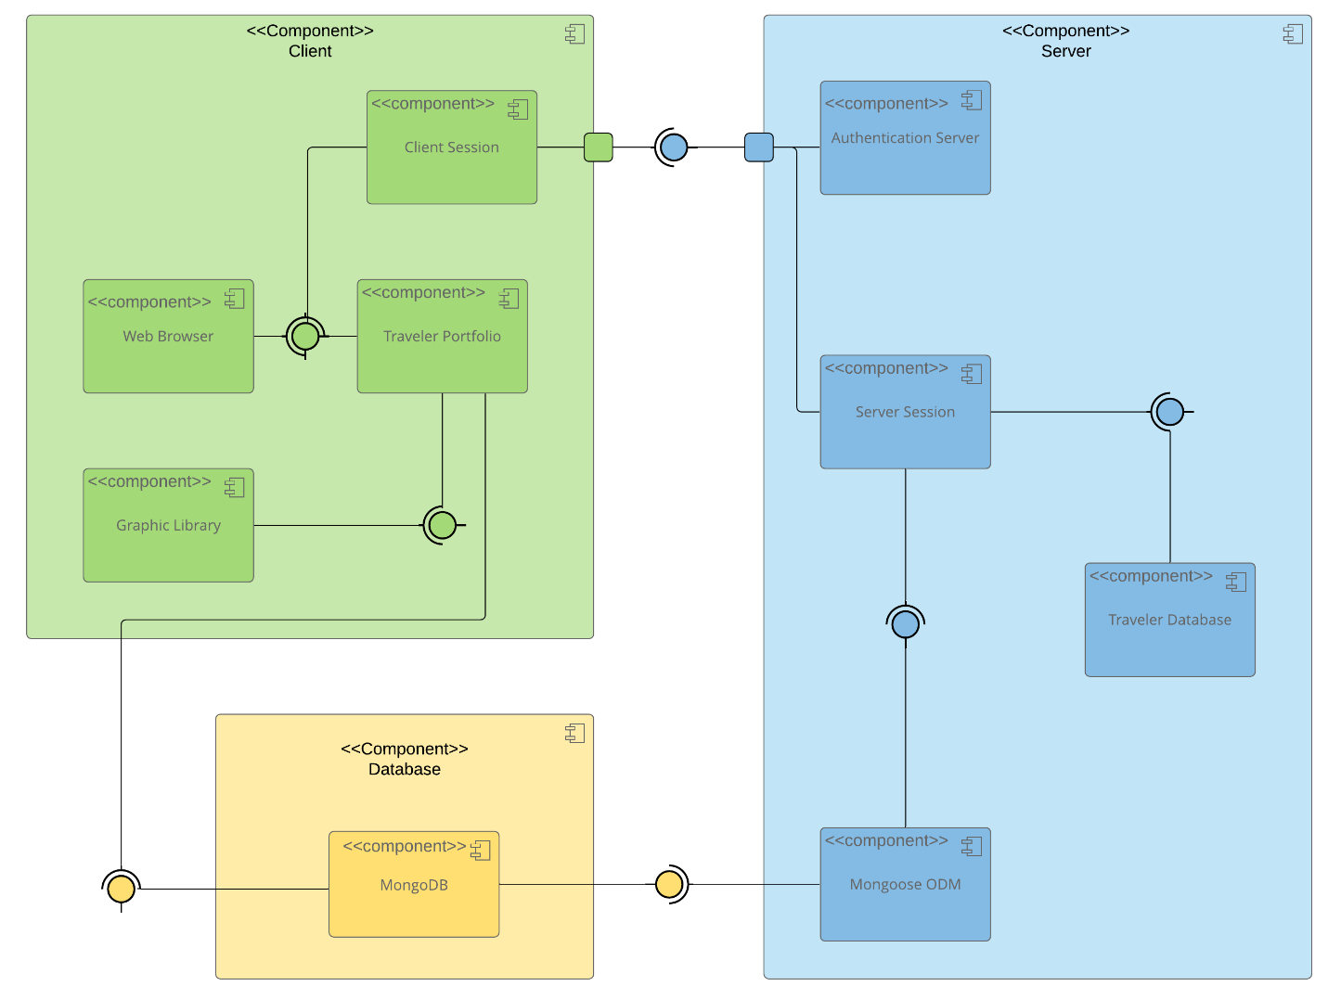

Sequence Diagram
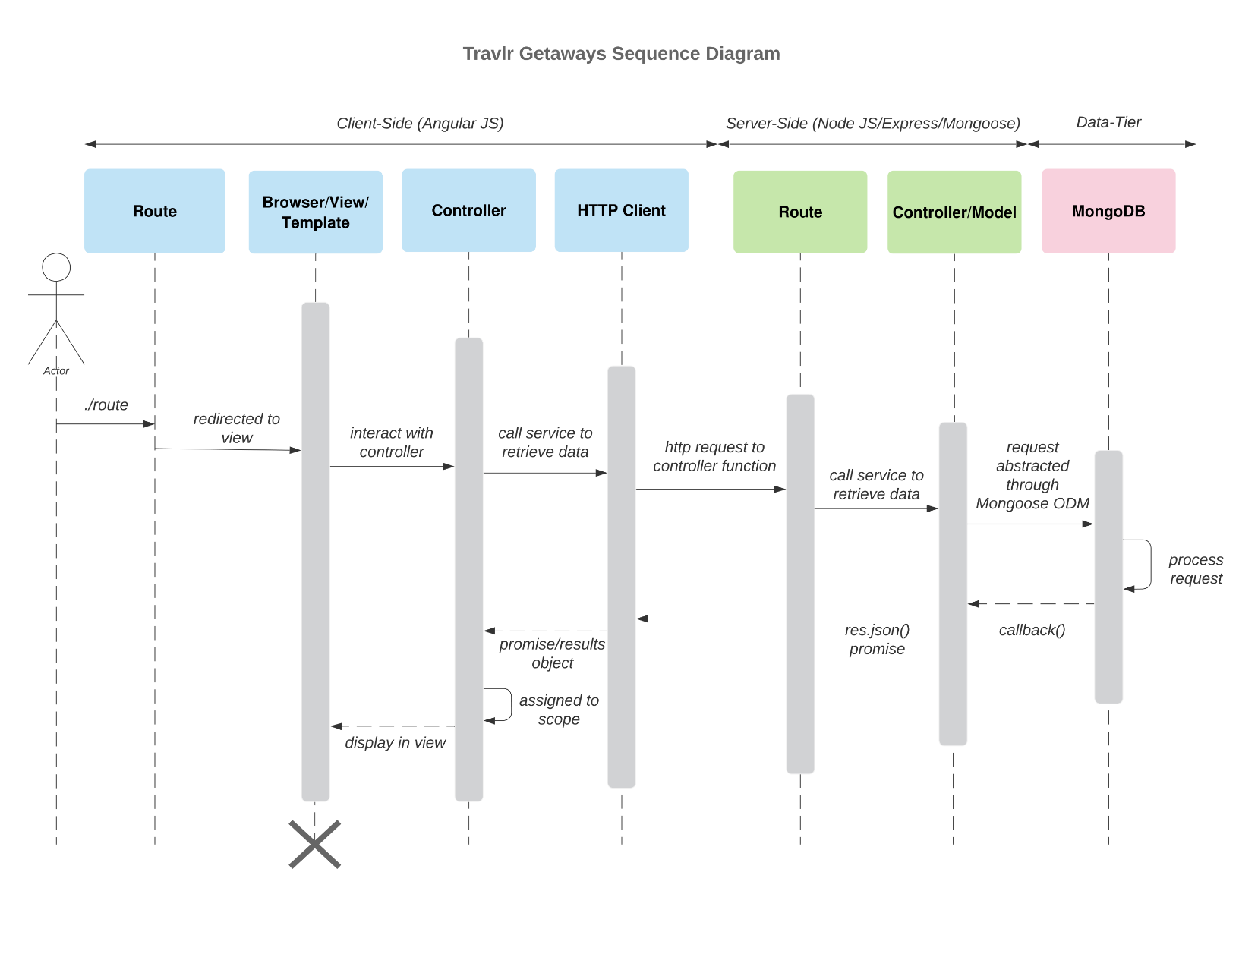The sequence diagram above shows how the client, server, and database work together. When a user opens a page, the view works with a controller to request the data it needs through an HTTP client. The server receives that request and uses Mongoose to get the records from MongoDB. The data comes back as JSON and is sent to the view for display. In our Travlr website, the Travel controller requests trip information from /api/trips and passes it to Handlebars to display on the page.

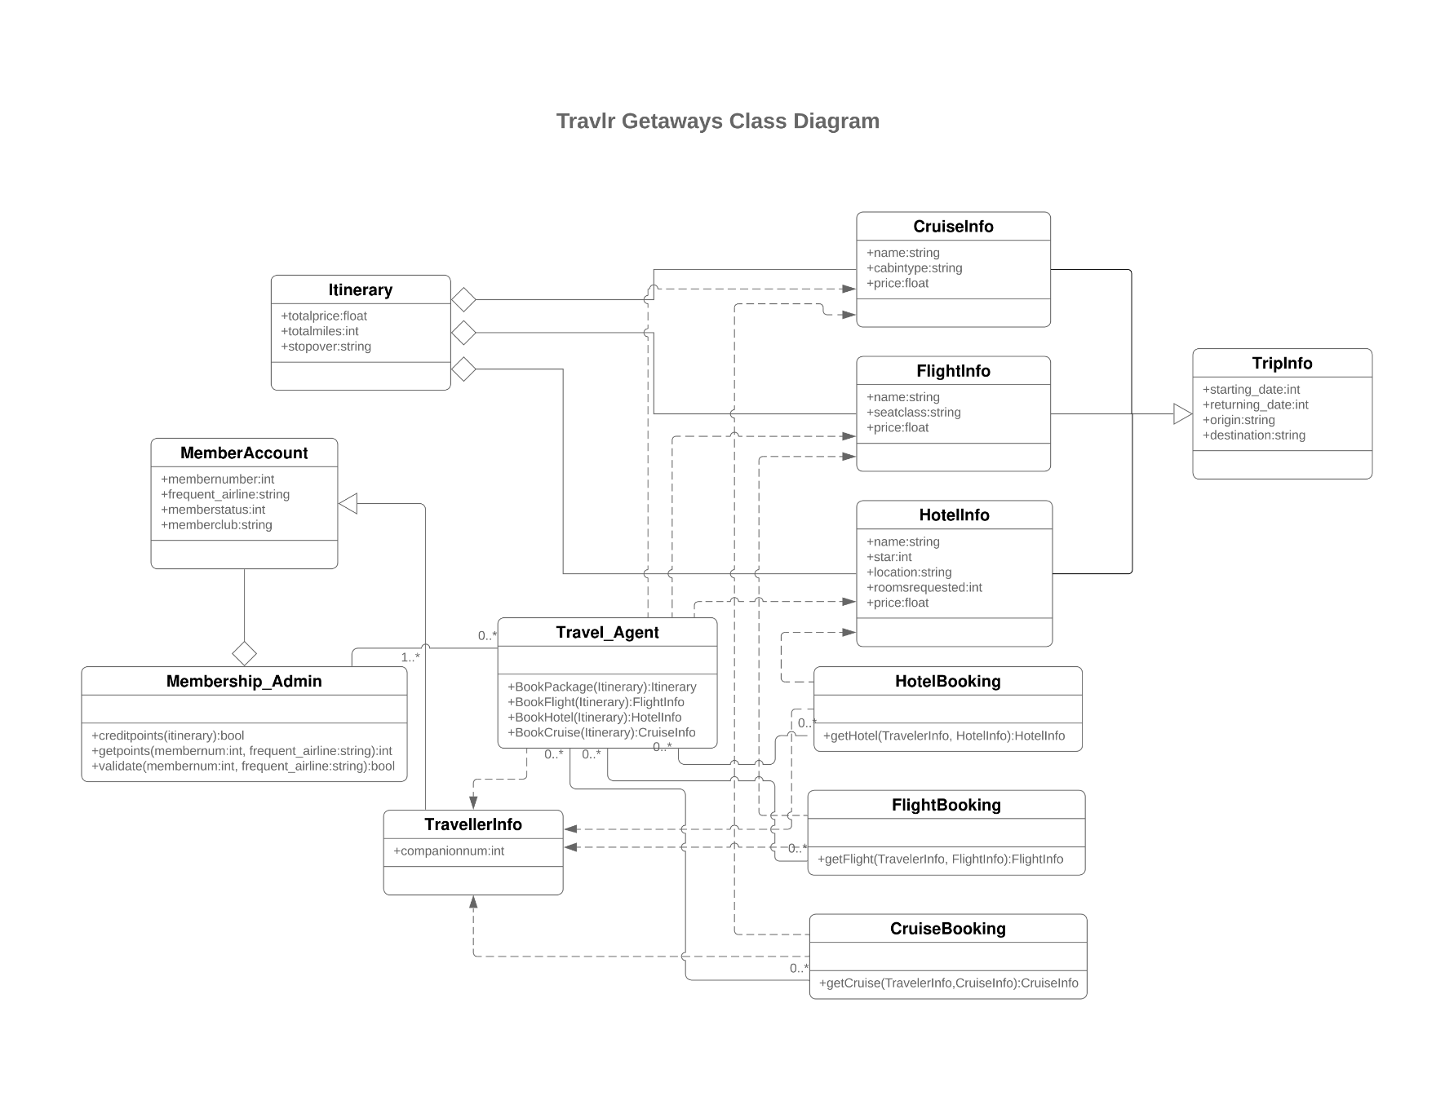
Class Diagram

The class diagram shows how the different parts of the travel system connect and work together. TripInfo stores the basic trip details, such as dates, origin, and destination. FlightInfo, CruiseInfo, and HotelInfo build on those details with information about flights, cruises, and hotels. Itinerary brings those parts together and keeps track of the total price, miles, and stopovers.
TravellerInfo holds companion information and builds on MemberAccount, which stores membership details. Membership_Admin handles membership validation and reward points. Travel_Agent works with HotelBooking, FlightBooking, and CruiseBooking to coordinate bookings using the traveler’s information and selected travel services.
The connections show which classes share information, depend on each other, or group other objects together. The numbers beside them show how many objects can be involved. This gives us a plan for the larger booking system as the application grows. So far, our application uses Express controllers and Mongoose to retrieve trips; the booking and membership features are still planned for later development.

API Endpoints

The REST API gives the customer-facing website a separate way to retrieve trip data from MongoDB. The two endpoints below are implemented in app_api and use the same trip model. During local development, their base address is http://localhost:3000. The tripCode parameter identifies a trip using its code field, such as GALR210214, rather than its MongoDB _id.

Method | Purpose | URL | Notes
GET | Get all trips | /api/trips | Returns all trips as JSON with a 200 status. If there are no trips, the list is empty. A database error returns 500.
GET | Retrieve a trip by its code | /api/trips/:tripCode | Returns the matching trip as JSON with a 200 status. We tested Gale Reef using GALR210214. We also tested INVALID, which returned 404 because no trip matched. A database error returns 500.

The User Interface

<Insert screenshots from the development of the SPA development to show the following: (1) a unique trip, added by you, (2) the Edit screen, and (3) the Update screen.>

<Summarize the Angular project structure and how it compares to the Express project structure. Be sure to describe the rich functionality provided by the SPA compared to a simple web application interaction. Describe the process of testing to make sure the SPA is working with the API to GET and PUT data in the database.>

